*** PLEASE DOWNLOAD THIS DOCUMENT FROM YOUR WEB BROWSER IF IT HAS NOT DONE SO AUTOMATICALLY ***

This layout is made using Microsoft Word. You will be dragging, rotating, and copying objects like
beds and flooring. If you are unfamiliar with this, do not worry – we will guide you step-by-step.

Depending on your settings, you may need to at the top of your screen in order to change the layout.

TIPS FOR BEGINNERS

- Copy: Duplicate an object by using Right-click > Copy then Right-click > Paste or Ctrl+C then Ctrl+V.

- Rotate: Click on the object, then drag the circular arrow above it

- Resize: Click on the object then drag the white corner points with your mouse. Do NOT to resize flooring or beds!

- Bring an object to the foreground: eg. to put the hoist “on top” of the flooring, Right Click > Bring to Front.

THINGS TO KEEP IN MIND

- Flooring should continue underneath the bed or chair to allow for the hoist and sling to be positioned over them. Remember, some beds have legs in the middle.

- Make sure the hoist wheels do not go off the side of the flooring - Move the hoist around by dragging it with the mouse. Rotate the hoist to simulate travelling from the bed to the wheelchair, or the bed to the bathroom, etc.

- Save your layout! For example: ‘Pelican Custom Flooring Plan – Bedroom – Client Name.docx’. Use the Save As command to make alternate layouts or new rooms, for example: ‘Pelican Custom Flooring Plan – Lounge – Client Name.docx’

- You can email your layout to sales@pelicanmanufacturing.com.au | Visit the Hard Plastic Flooring Webpage
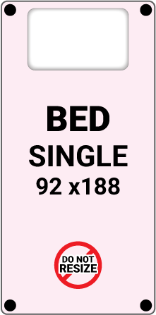
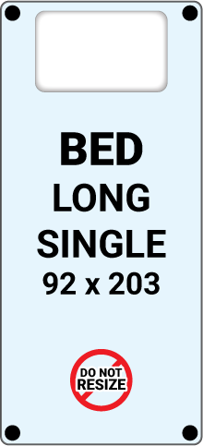
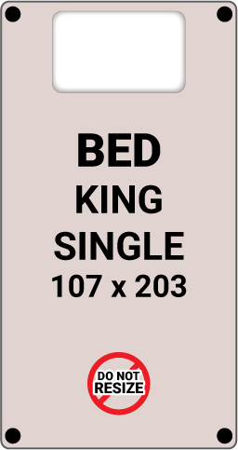
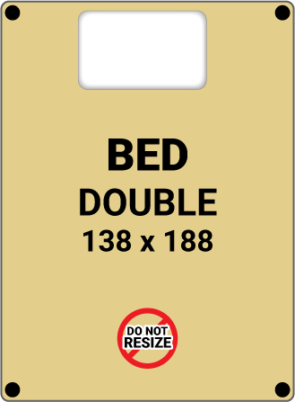
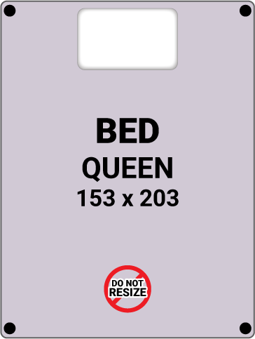



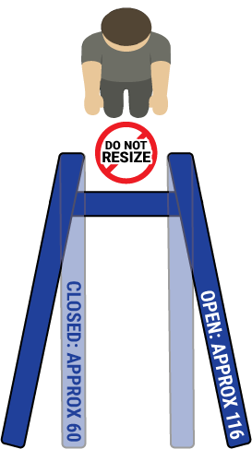
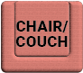
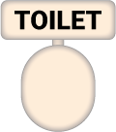


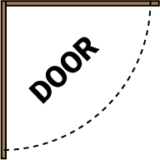


NOTES:

